DHC Requirements Document

(Draft 04/08/2019)

___________________________________________________________________

NOTES:

1. Requirements Definition Document (CU:Katy? + NREL)
   1. Consider the value proposition of this project’s Modelica based approach versus EnergyPlus alternative.
   2. Based on kickoff meeting conversation, we are likely targeting around the detailed design stage, as opposed to project screening. At least for now.
   3. Can documents circulated by Katy and Nick at kickoff meeting be a starting point?
   4. DOE is interested in getting a tool as the final outcome of the project. We may end up with the Modelica models (component, system) for DHS, but users will need Modelica tools to edit and run the models.
   5. Identify if there is a group of users who can use Dymola for the DHS project
   6. Finished product is word document
      1. Users cases based on the two case studies (CU: 1st; WM: 4th or 5th generation) – Note: more details on CU’s system is included in the System Architecture document.
      2. technique details of the systems
      3. Get a consistent definition of the DHS and its components (based on the literature review paper Nick recommended)

___________________________________________________________________

# Introduction and Framing

District heating and cooling (DHC) systems commonly involve a central plant that distributes steam, hot water, or chilled water to buildings by means of insulated pipes. In the United States, it is estimated that district energy serves around 5.5 billion square feet of floor space for heating and 1.9 billion square feet for cooling (ICF LLC and International District Energy Association 2018). Compared to local generation of hot and chilled water in buildings, DHC has numerous benefit, including reductions in valuable floorspace required to house equipment inside buildings, facilitating investment in lower-carbon resources by aggregating thermal loads for many buildings, and enhancing economic and environmental resiliency (Hall et al. 2015). Further, DHC systems can leverage “free” heating or cooling from waste streams (such as industrial processes) to serve the thermal needs in disparate buildings.

District energy systems are highly adopted in the United States and the connected building stock continues to grow. Figure 1 depicts existing DHC systems across the continental United States. As can be seen in Figure 1, college/university is the most common sector for DHC systems, but overall, the end-use markets served by DHC systems are diverse. While most district heating systems in the U.S. use steam, there is a trend towards hot water distribution (ICF LLC and International District Energy Association 2018). For cooling, the U.S. leads the world in district cooling via chilled water networks (ICF LLC and International District Energy Association 2018). In 2012, DHC systems across the U.S. provided over 187 million lb/hr of steam, 5,000 MMBtu/hr of hot water, 6,700 MW of electricity from combined heat and power (CHP), and 4 million tons of chilled water for the buildings they served (ICF LLC and International District Energy Association 2018).

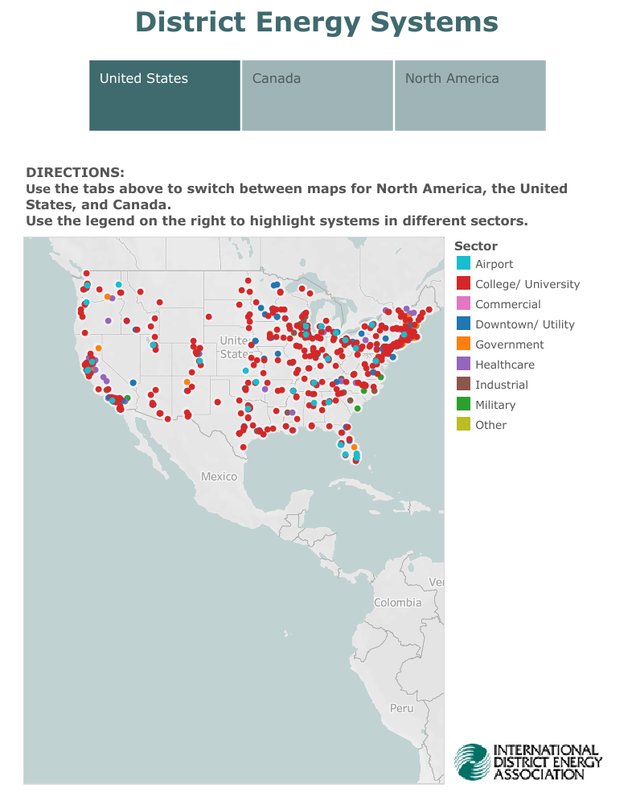

Figure 1: Map of district energy systems in the continental United States (International District Energy Association 2015).

District energy systems commonly evolve through five distinct phases, as summarized in Figure 2 below. The key activities, as summarized by Hall et al. (2015), are as follows. First in the initial assessment, primary activities include defining the district and goals, identifying barriers, and determining system potential. Second, appropriate technologies are selected, and the land is evaluated in feasibility studies. Third, the DHC system is taken from preliminary designs to fully-detailed construction plans during the often-iterative project development process. Some major activities during this phase may include concept design and analysis, cost-benefit analysis, procurement and project delivery, and implementing the project (Hall et al. 2015). Fourth during operation and optimization, system operators are heavily involved in maintaining, monitoring, adjusting system equipment. Often, the DHC system requires optimization based on the original goals and the current connected systems. Through the master planning, DHC systems are often expected to adapt and grow overtime with building renovations, additions, and subtractions. While the DHC may have been optimized during the design for its long-term target configuration, the optimal operating conditions naturally change with these changes to connected buildings. Lastly, the considerations of how DHC systems evolve over time lead into needs for expansion and renovation. This often includes developing new projects or systems, expanding operating systems, and connecting separate system.



Figure 2: Evolution of district energy systems through five primary phases.

Today, several phases of DHC systems necessitate their modeling and simulation. From the early planning stages through renovations, models can aid the creation of safe, reliable, and efficient DHC systems. … (discuss implementations of modeling/simulation at all DHC phases)…

(Limitations in modeling DHC systems today)

With these considerations in mind, the objective of this project is to create a new software analysis platform that enables developers of community-scale construction projects to evaluate and use shared thermal resources for improved community resilience and energy efficiency. This requirements document provides the initial platform for advising user and technological needs in DHC software tools. The remaining sections are as follows. First, we review existing literature on the design, analysis, and optimization of DHC systems. Then, we dive into existing modeling and simulation approaches in literature to understand the successes and failures of previous modeling attempts and identify opportunity spaces. Lastly, we transition from a technology focus to the users in order to guide the form and value proposition of our innovation into a product suitable for application.

# Literature Review & Technical Needs Assessment

## District Heating and Cooling System Design, Analysis, and Optimization

(Build upon/use Lit Rev prepared by Amy/Fatema/Nick/Maggie)

## Modeling & Simulation of District Heating and Cooling Systems

As we move from studying individual buildings to entire communities, new software tools are needed to perform integrated analysis. Software tools are available to perform detailed analysis of individual buildings (e.g. EnergyPlus) and urban-scale optimization of energy impacts (e.g. URBANopt); however, there are important limitations in the existing coupling of their analysis capabilities for performing fully-integrated, community-scale design. District energy networks inherently involve a collection of buildings, and the interactions among the interconnected buildings and the district energy plants are critical for system design and operation.

Table 1 below summarizes some of the recent DHC modeling endeavors from existing literature. The application, modeling objective, and open-source status vary among these prior works. District energy systems can be generally classified into five generations. While the distinctions among the five generations and terminology used varies across literature (Buffa et al. 2019), we adopt the definitions provided by __xxx__ for our work. Primarily, the generational definitions follow the evolution of district heating from high temperature, pressurized steam to low temperature and ambient water mediums. As DHC systems are generally moving towards 4th and 5th generation systems, much of the recent work has focused on these lower-temperature systems. Looking at modeling applications, large range of DHC phases. Some research aims to address early design and development phases such as urban planning (Schweiger, Runvik, et al. 2017) and early design development (Soons et al. 2014), while others look to provide control and optimization for DHC systems (Giraud et al. 2017; Ramm, Ehrenwirth, and Schrag 2019). The modeling requirements typically vary among these different stages. For example, the detailed pipe flow and internal building dynamics may be important for controls applications, but larger planning and design stages may only need high level dynamics to set the project’s direction.

Despite the presence of important dynamic processes in DHC systems, dynamic modeling is still rarely used for optimizing the design and operation of DHC systems (Mans et al. 2019). To ensure safe and reliable operation in the physical systems, operators need to continuously monitor and adjust setpoints, chemical compositions, valve positions, and various equipment settings. Further, DHC systems typically contain *n+1* redundancy in order to swap equipment when one component goes down, such as a chiller or a boiler. Providing heating and cooling services for many buildings, central plants need to adjust their supply to match the load on daily and seasonal bases. These operating dynamics are important considerations when modeling DHC systems.

Table 1: Basic information of select DHC models.

|  |  |  |  |  |  |
| --- | --- | --- | --- | --- | --- |
|  | **Name** | **Reference** | **Application / Generation(s)** | **Purpose/Objective** | **Open Source** |
| 1 | Control of a Central District Heating Station | (Ramm, Ehrenwirth, and Schrag 2019) | District Heating / 4th Generation | A close-to-reality control case is presented in order to test new control strategies for a district heating system. | Partially |
| 2 | Low Temperature Thermal Network Model Evaluation | (Rogers et al. 2019) | District Heating & Cooling / 3rd & 4th Generations | This work compares the performance of a four-pipe district energy system with a one-pipe low temperature thermal network to determine each systems’ impacts on total energy use and greenhouse gas emissions. | Partially |
| 3 | Automated Model Generation and Simplification | (Mans et al. 2019) | District Energy / 2nd Generation | A methodology is presented for automatically generating and simplifying models of complex and meshed thermal networks. | Yes1 |
| 4 | INDIGO Project Model | (del Hoyo Arce et al. 2018) | District Heating / 3rd Generation | New detailed and reduced order models for district heating applications are presented. | Unknown |
| 5 | Power-Based Heating Station Model | (Dahash, Steingrube, and Elci 2017) | District Heating / 3rd Generation | A heating station model is introduced for district heating systems in order to evaluate optimal power-based control strategies. | Yes |
| 6 | Framework for Aggregated, Dynamic Simulations | (Schweiger, Larsson, et al. 2017) | District Heating & Cooling / 4th Generation | A modeling framework for optimization of district energy systems is presented. | Yes |
| 7 | Dynamic Thermo-Hydraulic Pipe Model | (Van Der Heijde et al. 2017) | District Heating & Cooling / 4th Generation | This work presents a thermo-hydraulic model for thermal networks and compares its performance to experimental data and a commonly used model. | Yes |
| 8 | Framework for District Heating Dynamic Optimization | (Schweiger, Runvik, et al. 2017) | District Heating / 3rd or 4th Generation | The researchers develop a framework for creating and manipulating district heating networks for short-term production planning. | No |
| 9 | Exergy Analysis Tools | (Sangi et al. 2017) | District Heating / 3rd Generation | Hydraulic networks are automatically generated with few input parameters to perform dynamic exergy analysis. | No |
| 10 | *DistrictHeating* Library | (Giraud, Bavière, Vallée, et al. 2015) | District Heating / 2nd Generation | A district heating library is presented, validated, and applied to a sample district heating network. | No |
| 11 | Virtual District Heating Model for Control Evaluation | (Giraud, Bavière, Paulus, et al. 2015) | District Heating / 2nd Generation | Effective control strategies are developed by dynamic modeling, experimental validation, and simulation of a district heating network. | No |
| 12 | District Heating Artificial Neural Network | (Strušnik and Avsec 2015) | District Heating / 3rd Generation | Thermo-economic analyses are performed for district heating mony flows using artificial neural networks. | No |
| 13 | Early-Design Simulations of District Heating System | (Soons et al. 2014) | District Heating /  2nd - 4th Generations | Simulations of district heating central plants with and without thermal energy storage are compared to optimize utilization of a biomass gasifier to inform early-designs. | Yes |

1 Only the base models are open source.

Tools for simulation and optimization can generally be categorized into three types: (1) single-domain tools, (2) multi-domain tools, and (3) urban design and planning tools (Allegrini et al. 2015). Single-domain tools naturally meet the specific needs of the intended application but can be limited in their limited flexibility and ability to create new models. For example, EnergyPlus (Crawley et al. 2001) does not model the electric grid and have limitations in the number of buildings it can simultaneously model; meanwhile, OpenDSS (Dugan and Montenegro 2018) and GridLab-D (Chassin, Schneider, and Gerkensmeyer 2008) focus on the electrical distribution, but only include simplified building and heating models (Bonvini and Wetter 2015). For these reasons, multidomain tools, as the name implies, can model and simulated integrated systems, which is suitable for district energy applications. Multidomain tools can be “general” – such as with Modelica, Matlab, or TRNSYS – or “specific” – such as with SynCity, or CitySim. In addition to their flexibility, many general multidomain tools also have the benefit of being structed in libraries, which aids the exchange of ideas and methods among the scientific community and industrial developments (Schweiger, Larsson, et al. 2017). Furthermore, Modelica, Matlab, and TRNSYS can be used in co-simulation using the Functional Mock-up Interface (FMI), which further expands their application possibilities.

For the reasons listed above, general multidomain modeling tends to be the preferred approach for DHC applications. The chosen modeling approach for select literature is summarized in Table 2 below. For more information, modeling and simulation of DHC systems have been well summarized in several works (Allegrini et al. 2015; Olsthoorn, Haghighat, and Mirzaei 2016). Modelica with Dymola as the compiler is one of the most popular approaches. Through a functional comparison of several general simulation tools (Modelica/Dymola, Matlab/Simulink, and TRNSYS), Soons et al. (2014) found that Modelica performed better in terms of modularity, multidomain modeling, realistic control behavior, and flexibility. Similarly, Schweiger et al. (2018) performed detailed comparisons between Simulink, TRNSYS, IDA ICE, and Modelica for their effectiveness in modeling and simulating district energy systems. Their results showed that the Modelica model showed the highest fidelity and is very suitable for all applications considered (with the exception being limited suitability for building models), while TRNSYS has limited suitability for power distribution and co-simulation. Further, Schweiger et al. (2018) found that IDA ICE and Matlab/Simulink have limited suitability for DHC systems. Based on these results, the intent of our work was to focus on Modelica implementations for modeling DHC.

Table 2: Summary of select modeling approaches in district energy applications. Numbered references shown in parenthesis are repeat sources that use multiple modeling approaches.

|  |  |  |  |
| --- | --- | --- | --- |
|  | **Modeling Approach** | **Model Name** |  |
| 1 | Modelica/Dymola | Control of a Central District Heating Station | (Ramm, Ehrenwirth, and Schrag 2019) |
| 2 |  | Automated Model Generation and Simplification | (Mans et al. 2019) |
| 3 |  | INDIGO Project Model | (del Hoyo Arce et al. 2018) |
| 4 |  | Power-Based Heating Station Model | (Dahash, Steingrube, and Elci 2017) |
| 5 |  | Framework for Aggregated, Dynamic Simulations | (Schweiger, Larsson, et al. 2017) |
| 6 |  | Dynamic Thermo-Hydraulic Pipe Model | (Van Der Heijde et al. 2017) |
| 7 |  | Framework for District Heating Dynamic Optimization | (Schweiger, Runvik, et al. 2017) |
| 8 |  | Exergy Analysis Tools | (Sangi et al. 2017) |
| 9 |  | *DistrictHeating* Library | (Giraud, Bavière, Vallée, et al. 2015) |
| 10 |  | Virtual District Heating Model for Control Evaluation | (Giraud, Bavière, Paulus, et al. 2015) |
| 11 |  | Early-Design Simulations of District Heating System | (Soons et al. 2014) |
| (6) | Modelica/JModelica | Framework for Aggregated, Dynamic Simulations | (Schweiger, Larsson, et al. 2017) |
| (8) |  | Framework for District Heating Dynamic Optimization | (Schweiger, Runvik, et al. 2017) |
| 12 | Modelica/Undisclosed Compiler | Low Temperature Thermal Network Model Evaluation | (Rogers et al. 2019) |
| 13 | Matlab/Simulink | District Heating Artificial Neural Network | (Strušnik and Avsec 2015) |
| (6) | Python | Framework for Aggregated, Dynamic Simulations | (Schweiger, Larsson, et al. 2017) |
| (8) |  | Framework for District Heating Dynamic Optimization | (Schweiger, Runvik, et al. 2017) |

Various component and system models for DHC applications exist in open-source Modelica libraries today. This includes the Modelica Standard Library (MSL); the IBPSA (International Building Performance Simulation Association) project libraries included in Annex 60 (Wetter et al. 2015) and Project 1 (IBPSA 2016); TransiEnt (Andresen et al. 2015); the District Cooling Open Source Library (DCOL) (Febres et al. 2017), and ThermoCycle (Quoilin et al. 2014). Several open-source libraries came out of the IBPSA projects, all of which have relevance to DHC systems. These include the Buildings Library (Wetter et al. 2014), BuildingSystems Library (Nytsch-Geusen et al. 2013), AixLib (Müller et al. 2016), and the Integrated District Energy Assessment Simulations (IDEAS) library (Van Roy, Verbruggen, and Driesen 2013).

Each of the above-mentioned libraries have been previously implemented in DHC modeling and simulation. To name a few, the MSL contains basic DHC elements, such as dynamic pipes, storage vessels, and pumps, that have been adopted in several works (Dahash, Steingrube, and Elci 2017; Rogers et al. 2019). The BuildingSystems library contains a CHP models suitable for dynamic simulation, as applied by Ramm, Ehrenwirth, and Schrag (2019). As the name implies, the IDEAS library is designed for district energy systems and contains various DHC components such as chillers, heat pumps, heat exchangers, and geothermal systems. While these libraries provide a valuable foundation for DHC modeling, the resources are notably scattered and arguably incomplete in their component inclusion and documentation.

# User Needs Assessment

## Qualitative Research

In order to inform our product’s needs and the opportunity space, we will conduct interviews with various user groups involved with district energy systems. This may include master planners, urban planners, early design engineers, detailed design engineers, operators, and facility managers. The objective of these interviews will be to identify barriers and opportunities, and to deepen our understanding of the design and operation of DHC systems. This qualitative research will be used to develop opportunity spaces in DHC technology from the users’ perspective.

Beyond interviews, we will also observe local DHC systems to inform our product’s needs. There are several local DHC systems that can be surveyed. On CU Boulder’s campus, there are three central utility plants that serve two independent DHC networks. The main CU campus has two interconnected central utility plants that provide steam, chilled water, and electricity for campus administrative, academic, research, and athletic facilities. In addition to the main campus, the Williams Village campus has a smaller DHC network serving dormitory buildings, a cafeteria, and a recreation center. By observing these facilities, we can gain insights into their operational flow, control interfaces, and system modeling requirements.

## Preliminary Findings

From preliminary research and observations, there are several insights from the planning and design phases of DHC systems that we noted: (1) There are many, custom tools that engineers use to develop DHC systems. These often-disconnected resources are highly tailored per the user’s expert knowledge. (2) While the long-term vision for community greatly affects the central plant’s design and equipment needs, the master plan is not always realized. For example, the Williams Village DHC system was designed for around three times the square footage that it serves today, but the development didn’t proceed as expected. The flexibility in service capacity can be a key requirement for DHC systems. (3) Not only do the DHC components need to be flexible in its overall capacity over time, but the components are highly variable across existing systems. In the United States in 2012, DHC systems were powered by 16 different fuel types, including natural gas, biomass, landfill gas, solar thermal, electricity, fuel oil, coal, and lake water (ICF LLC and International District Energy Association 2018). With these many inputs, there are compounding numbers of equipment varieties that can be present in DHC systems. This component variety occurs not only across different DHC systems, but within DHC systems as well. For example, some equipment from CU’s DHC plant are shown in Figure 3 and Figure 4 below. The chilled water production changes among chillers and water-side economizer heat exchangers (pictured in Figure 3) depending on the load needs and ambient conditions.

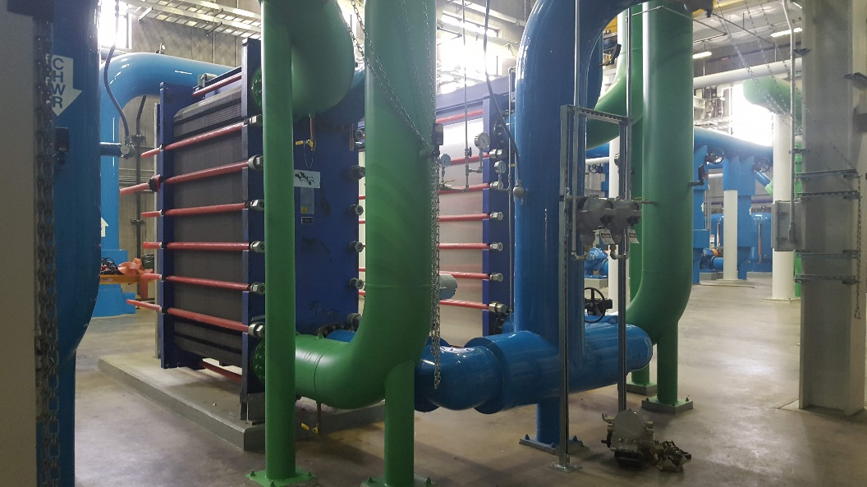

Figure 3: Water-side economizer heat exchangers that provide “free cooling” for chilled-water production.

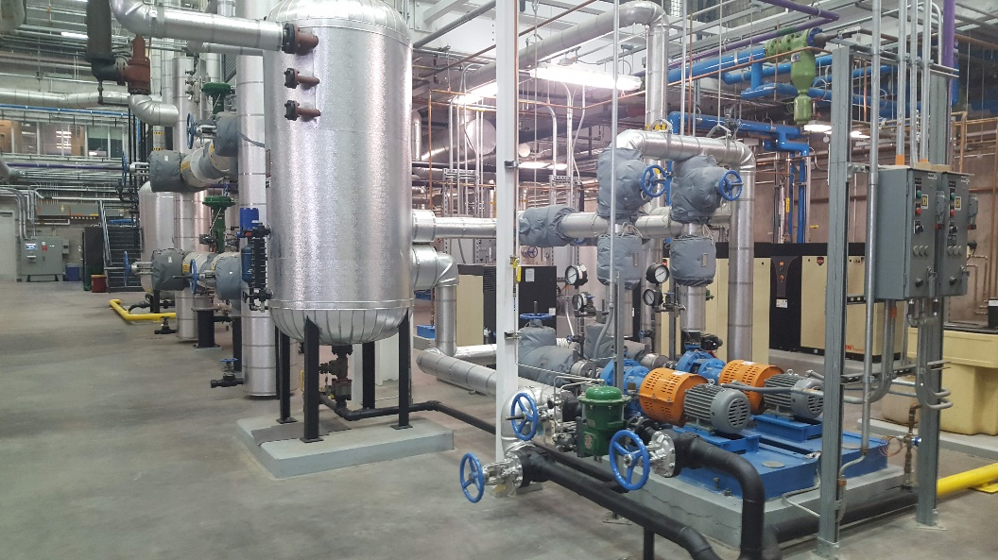

Figure 4: Various equipment for steam production, including pumps and expansion tanks.

Beyond planning and design, we gained several preliminary insights into the operational optimization and control needs. (1) Safety and reliability are of the highest priority, followed by efficiency. (2) The control systems are often hierarchical and often involve many levels of redundancy to ensure reliable operation. For example, some of CU’s DHC control interfaces are included in Figure 5 below. These equipment-level stations transmit high level data to a central control station, where the operators can manage the entire plant. For redundancy, these control systems include decoupled loops in the wiring. (3) Beyond the automated controls, the operators’ rounds provide critical feedback for the systems’ operating conditions that current sensor technology cannot yet provide. For example, there is feedback from the sound, smell, equipment vibrations, and chemical readings that are necessary to ensure the health and safety of the DHC plant today and for its future.

|  |  |
| --- | --- |
|  |  |
| (a) | (b) |
| Figure 5: Equipment-level control stations for (a) a chilled-water system and (b) steam boilers. | |

# Conclusion

(NREL, as needed per flow and content of overall report)

# References

Allegrini, Jonas, Kristina Orehounig, Georgios Mavromatidis, Florian Ruesch, Viktor Dorer, and Ralph Evins. 2015. “A Review of Modelling Approaches and Tools for the Simulation of District-Scale Energy Systems.” *Renewable and Sustainable Energy Reviews* 52: 1391–1404. https://doi.org/10.1016/J.RSER.2015.07.123.

Andresen, Lisa, Pascal Dubucq, Ricardo Peniche Garcia, Günter Ackermann, Alfons Kather, and Gerhard Schmitz. 2015. “Status of the TransiEnt Library: Transient Simulation of Coupled Energy Networks with High Share of Renewable Energy.” In *Proceedings of the 11th International Modelica Conference*, 695–705. Versailles, France. https://doi.org/10.3384/ecp15118695.

Bonvini, Marco, and Michael Wetter. 2015. “Gradient-Based Optimal Control of Batteries and HVAC in District Energy Systems.” In *14th Conference of International Building Performance Simulation Association*, 363–70. Hyderabad, India.

Buffa, Simone, Marco Cozzini, Matteo D’Antoni, Marco Baratieri, and Roberto Fedrizzi. 2019. “5th Generation District Heating and Cooling Systems: A Review of Existing Cases in Europe.” *Renewable and Sustainable Energy Reviews* 104 (April): 504–22. https://doi.org/10.1016/J.RSER.2018.12.059.

Chassin, D. P., K. Schneider, and C. Gerkensmeyer. 2008. “GridLAB-D: An Open-Source Power Systems Modeling and Simulation Environment.” In *Transmission and Distribution Exposition Conference: 2008 IEEE PES Powering Toward the Future, PIMS 2008*, 1–5. Chicago, IL, USA. https://doi.org/10.1109/TDC.2008.4517260.

Crawley, Drury B., Linda K. Lawrie, Frederick C. Winkelmann, W.F. Buhl, Y.Joe Huang, Curtis O. Pedersen, Richard K. Strand, et al. 2001. “EnergyPlus: Creating a New-Generation Building Energy Simulation Program.” *Energy and Buildings* 33 (4): 319–31. https://doi.org/10.1016/S0378-7788(00)00114-6.

Dahash, Abdulrahman, Annette Steingrube, and Mehmet Elci. 2017. “A Power-Based Model of a Heating Station for District Heating (DH) System Applications.” In *Proceedings of the 12th International Modelica Conference*, 415–24. Prague, Czech Republic. https://doi.org/10.3384/ecp17132415.

Dugan, Roger C, and Davis Montenegro. 2018. “Reference Guide: The Open Distribution System Simulator (OpenDSS).” http://download2.nust.na/pub4/sourceforge/e/el/electricdss/OpenDSS/OpenDSSManual.pdf.

Febres, Jesus, Eduardo Ubieta, Raymond Sterling, Itzal del Hoyo, and Susana López. 2017. “District Cooling Open Source Library (DCOL),” June. https://doi.org/10.5281/ZENODO.818289.

Giraud, Loïc, Roland Bavière, Cédric Paulus, Mathieu Vallée, and Jean-François Robin. 2015. “Dynamic Modelling, Experimental Validation and Simulation of a Virtual District Heating Network.” In *The 28th International Conference on Efficiency, Cost, Optimization, Simulation and Environmental Impact of Energy Systems*. Pau, France.

Giraud, Loïc, Roland Bavière, Mathieu Vallée, and Cédric Paulus. 2015. “Presentation, Validation and Application of the DistrictHeating Modelica Library.” In *Proceedings of the 11th International Modelica Conference*, 79–88. Versailles, France. https://doi.org/10.3384/ecp1511879.

Giraud, Loïc, Massinissa Merabet, Roland Baviere, and Mathieu Vallée. 2017. “Optimal Control of District Heating Systems Using Dynamic Simulation and Mixed Integer Linear Programming.” In *Proceedings of the 12th International Modelica Conference*, 141–50. Prague, Czech Republic. https://doi.org/10.3384/ecp17132141.

Hall, Abby, Clark Wilson, Andrea Gardner, Akima Cornell, Jon Swae, Jordan O’Brien, and Ellen Greenberg. 2015. “District-Scale Energy Planning: Smart Growth Implementation Assistance to the City of San Francisco.” Washington DC. www.epa.gov/smartgrowth.

Heijde, B Van Der, M Fuchs, C Ribas Tugores, G Schweiger, K Sartor, D Basciotti, D Müller, C Nytsch-Geusen, M Wetter, and L Helsen. 2017. “Dynamic Equation-Based Thermo-Hydraulic Pipe Model for District Heating and Cooling Systems.” *Energy Conversion and Management* 151: 158–69. https://doi.org/10.1016/j.enconman.2017.08.072.

Hoyo Arce, Itzal del, Saioa Herrero López, Susana López Perez, Miika Rämä, Krzysztof Klobut, and Jesus A. Febres. 2018. “Models for Fast Modelling of District Heating and Cooling Networks.” *Renewable and Sustainable Energy Reviews* 82 (February): 1863–73. https://doi.org/10.1016/j.rser.2017.06.109.

IBPSA. 2016. “IBPSA Project 1.” 2016. https://ibpsa.github.io/project1/index.html.

ICF LLC, and International District Energy Association. 2018. “U.S. District Energy Services Market Characterization.” Washington DC. https://www.eia.gov/analysis/studies/buildings/districtservices/pdf/districtservices.pdf.

International District Energy Association. 2015. “System Maps: Map of District Energy in North America.” 2015. https://www.districtenergy.org/resources/resources/system-maps.

Lund, Henrik, Neven Duic, Poul Alberg Østergaard, and Brian Vad Mathiesen. 2018. “Future District Heating Systems and Technologies: On the Role of Smart Energy Systems and 4th Generation District Heating.” *Energy* 165 (December): 614–19. https://doi.org/10.1016/J.ENERGY.2018.09.115.

Mans, Michael, Tobias Blacha, Peter Remmen, and Dirk Müller. 2019. “Automated Model Generation and Simplification for District Heating and Cooling Networks.” In *Proceedings of the 13th International Modelica Conference*, 157:179–86. Regensburg, Germany. https://doi.org/10.3384/ecp19157179.

Müller, D, M Lauster, A Constantin, M Fuchs, and P Remmen. 2016. “AIXLIB – An Open-Source Modelica Library within the IEA-EBC Annex 60 Framework.” In *BauSIM*, 3–9. Dresden, Germany.

Nytsch-Geusen, Christoph, Jörg Huber, Manuel Ljubijankic, and Jörg Rädler. 2013. “Modelica BuildingSystems - Eine Modellbibliothek Zur Simulation Komplexer Energietechnischer Gebäudesysteme.” *Bauphysik* 35 (1): 21–29. https://doi.org/10.1002/bapi.201310045.

Olsthoorn, Dave, Fariborz Haghighat, and Parham A. Mirzaei. 2016. “Integration of Storage and Renewable Energy into District Heating Systems: A Review of Modelling and Optimization.” *Solar Energy* 136 (October): 49–64. https://doi.org/10.1016/J.SOLENER.2016.06.054.

Quoilin, Sylvain, Adriano Desideri, Jorrit Wronski, Ian Bell, and Vincent Lemort. 2014. “ThermoCycle: A Modelica Library for the Simulation of Thermodynamic Systems.” In *Proceedings of the 10th International Modelica Conference*, 683–92. Lund, Sweden. https://doi.org/10.3384/ECP14096683.

Ramm, Tobias, Mathias Ehrenwirth, and Tobias Schrag. 2019. “Modelling of the Central Heating Station within a District Heating System with Variable Temperatures.” In *Proceedings of the 13th International Modelica Conference*, 567–76. Regensburg, Germany. https://doi.org/10.3384/ecp19157567.

Rogers, Ryan, Vickram Lakhian, Marilyn Lightstone, and James S. Cotton. 2019. “Modeling of Low Temperature Thermal Networks Using Historical Building Data from District Energy Systems.” In *Proceedings of the 13th International Modelica Conference*, 157:543–50. Regensburg, Germany. https://doi.org/10.3384/ecp19157543.

Roy, Juan Van, Bart Verbruggen, and Johan Driesen. 2013. “Ideas for Tomorrow: New Tools for Integrated Building and District Modeling.” *IEEE Power and Energy Magazine* 11 (5): 75–81. https://doi.org/10.1109/MPE.2013.2268815.

Sangi, Roozbeh, Pooyan Jahangiri, Alexander Thamm, and Dirk Müller. 2017. “Dynamic Exergy Analysis – Modelica®-Based Tool Development: A Case Study of CHP District Heating in Bottrop, Germany.” *Thermal Science and Engineering Progress* 4 (July): 231–40. https://doi.org/10.1016/j.tsep.2017.10.008.

Schweiger, Gerald, Richard Heimrath, Basak Falay, Keith O’Donovan, Peter Nageler, Reinhard Pertschy, Georg Engel, Wolfgang Streicher, and Ingo Leusbrock. 2018. “District Energy Systems: Modelling Paradigms and General-Purpose Tools.” *Energy* 164 (December): 1326–40. https://doi.org/10.1016/J.ENERGY.2018.08.193.

Schweiger, Gerald, Per-Ola Larsson, Fredrik Magnusson, Patrick Lauenburg, and Stéphane Velut. 2017. “District Heating and Cooling Systems – Framework for Modelica-Based Simulation and Dynamic Optimization.” *Energy* 137 (October): 566–78. https://doi.org/10.1016/j.energy.2017.05.115.

Schweiger, Gerald, Håkan Runvik, Fredrik Magnusson, Per-Ola Larsson, and Stéphane Velut. 2017. “Framework for Dynamic Optimization of District Heating Systems Using Optimica Compiler Toolkit.” In *Proceedings of the 12th International Modelica Conference*, 131–39. Prague, Czech Republic. https://doi.org/10.3384/ecp17132131.

Soons, F F M, J Ignacio Torrens, J L M Hensen, and R A M De Schrevel. 2014. “A Modelica Based Computational Model for Evaluating a Renewable District Heating System.” In *Proceedings of the 9th International Conference on System Simulation in Buildings*, 1–16. Liege, Belgium. https://pure.tue.nl/ws/portalfiles/portal/3980938/899836577909065.pdf.

Strušnik, Dušan, and Jurij Avsec. 2015. “Artificial Neural Networking Model of Energy and Exergy District Heating Mony Flows.” *Energy and Buildings* 86 (January): 366–75. https://doi.org/10.1016/J.ENBUILD.2014.09.075.

Wetter, Michael, Marcus Fuchs, Pavel Grozman, Lieve Helsen, Filip Jorissen, Moritz Lauster, Dirk Müller, et al. 2015. “IEA EBC Annex 60 Modelica Library - An International Collaboration to Develop a Free Open-Source Model Library for Buildings and Community Energy Systems.” In *14th Conference of International Building Performance Simulation Association*, 395–402. Hyderabad, India. https://github.com/iea-annex60/.

Wetter, Michael, Wangda Zuo, Thierry S Nouidui, and Xiufeng Pang. 2014. “Modelica Buildings Library.” *Journal of Building Performance Simulation* 7 (4): 253–70. https://doi.org/10.1080/19401493.2013.765506.